Project Phase-1 (18CS703) Report

on

## Identification of dog’s breed using

## CNN with bi-directional lstm

#### *Submitted to*

**NMAM INSTITUTE OF TECHNOLOGY, NITTE**

(An Autonomous Institution under VTU, Belagavi)

*In partial fulfillment of the requirements for the award of the*

Degree of Bachelor of Engineering

in

Computer Science and Engineering

#### *by*

**HAWARALU VIGNESH 4NM18CS064**

**PRIYANAKA NAGESH 4NM18CS122**

**KEDAAR KAMATH 4NM18CS076**

**M ADITYA NAIK 4NM18CS082**

Under the guidance of

**Ms. Manasa GR,**

**Asst. Professor**

Dept. of CSE, NMAMIT, NITTE



CERTIFICATE

Certified that the project work entitled **………..** is a bonafide work carried out by Hawaralu Vignesh(4NM18CS064), Priyanka Nagesh(4NM18CS122),

Kedaar Kamath(4NM18CS076), M Aditya Naik(4NM18CS082) in partial fulfillment for the award of Degree of Bachelor of Engineering in Computer Science and Engineering of the Visvesvaraya Technological University, Belagavi during the year 2019-20.It is certified that all corrections/suggestions indicated for Internal Assessment have been incorporated in the report deposited in the departmental library. The project report has been approved as it satisfies the academic requirements in respect of Project Phase- 1 (18CS703) prescribed for the said Degree.

**Name & Signature of Guide Signature of HOD** **Signature of the Principal**

**External Viva**

**Name of the Examiners** **Signature with Date**

1. *_______________________________ ________________________________*

*2.. _______________________________ ________________________________*

**ACKNOWLEDGEMENT**

The satisfaction that accompanies the completion of any task would be incomplete without the mention of all the people, without whom this endeavour would have been a difficult one to achieve. Their constant blessings, encouragement, guidance and suggestions have been a constant source of inspiration

First and foremost, my gratitude to my project guide, **MS. Manasa GR** for his constant guidance throughout the course of this project Phase-1 and for the valuable suggestions.

I also take this opportunity to express a deep sense of gratitude to the project coordinators for their valuable guidance and support.

I acknowledge the support and valuable inputs given by, **Dr Jyothi Shetty** the Head of the Department, Computer Science and Engineering, NMAMIT, Nitte.

My sincere thanks to our beloved principal, **Dr. Niranjan N Chiplunkar** for permitting us to carry out this project at our college and providing us with all needed facilities.

Finally, thanks to staff members of the Department of Computer Science and Engineering and our friends for their honest opinions and suggestions throughout the course of our project Phase-1.

Hawaralu Vignesh (4NM18CS064)

Priyanka Nagesh (4NM18CS122)

Kedaar Kamath (4NM18CS076)

M Aditya Naik(4NM18CS082)

**ABSTRACT**

Dogs are domesticated mammals, not natural wild animals. Today, some dogs are used as pets, others are used to help humans do their work. It’s a significant task for the owners to care and maintain their pet dog.For that, they need to know the breed of the dog to train and cure disease.Aim is identifying the breed of a dog in a given image which includes convolution neural networks.The Network is trained and evaluated on the Dog-breed data set to identify the breed. To achieve satisfactory results, it is important to properly prepare and transform the data to the appropriate format. The processing steps for the sentence descriptions and images are outlined in the following sections.

Convolutional neural networks and an LSTM are the core networks in this research for image feature encodings and language translation respectively.In this Task, we were provided a strictly canine subset of Image-Net in order to practice fine-grained image categorization. With 120 breeds of dogs and a limited number training images per class, we might find the problem more challenging than we anticipated.

Convolutional Neural Networks ( CNNs ) gives single often used methods for image classification and detection. In this exertion , we define a CNN based approach for spotting dogs in perchance complex images and due to this fact reflect inconsideration on the identification of the one of kinds of dog breed. The experimental outcomeanalysis supported the standard metrics and thus the graphical representation confirms that the algorithm ( CNN ) gives good analysis accuracy for all the tested datasets.



**CONTENT**

|  |  |  |
| --- | --- | --- |
| **CHAPTER NO.** | **CHAPTER NAME** | **PAGE NO.** |
| **1** | **INTRODUCTION** | **1** |
| **2** | **LITERATURE SURVEY** | **2-6** |
| **3** | **PROBLEM DEFINITION** | **7** |
| **4** | **SYSTEM REQUIREMENTS SPECIFICATION** | **8-9** |
| **5** | **SYSTEM DESIGN** | **10-11** |
| **6** | **CONCLUSIONS** | **12** |
|  | **REFERENCES** |  |

**CHAPTER 1- INTRODUCTION**

Machine learning may be a sub field of AI (AI). The goal of machine learning generally is to know the structure of knowledge and fit that data into models which will be understood and utilized by people. Although machine learning may be a field within computing, it differs from traditional computational approaches. In traditional computing, algorithms are sets of explicitly programmed instructions employed by computers to calculate or problem solve. Machine learning algorithms instead leave computers to coach on data inputs and use statistical analysis so as to output values that fall within a selected range. Because of this, machine learning facilitates computers in building models from sample data so as to automate decision-making processes supported data inputs.

Most of the dog breeds are developed in order to drive some specific things. Knowing the breed of dog can help us to predict and understand the behavior. And this is essential when it comes to managing and training dogs for specific tasks. In machine learning, Convolutional Neural Network (CNN) is complicated feed forward neural networks. CNNs are used for image classification and recognition due to its excessive accuracy. The CNN follows a hierarchical model which struggles on constructing a network, sort of a funnel, and eventually offers out a definitely related layer the place all the neurons are linked to each and every different and consequently the output is processed A computer learns to classify images, text and sound. The pc is trained with large image datasets then it changes the pixel value of the image to an indoor representation, where the classifier can detect patterns on the input image. We proposed a model that uses CNN network to classify Images between Human and Dogs. Our main aim is to build an android application using which a user can identify the breed of a dog.

**CHAPTER 2- LITERATURE SURVEY**

For this project, we reviewed five of existing journals namely “Dog breed identification, by Whitney LaRow,Vijay”, “Identifying dog breed using CNN Architecture, by Kanika Bhavya”, “Dog breed Identification using DenseNet, by WentingShi and MuyunLiu”, “Dog Breed Identification using CNN and WebScraping, by Praveen and “Convolutional Neural Network with Bi-directional Long Short-Term Memory Approach for Image Captioning, by Suramya Patel”.

**Dog breed identification, by Whitney LaRow,Vijay**

This project uses computer vision and machine learning techniques to predict dog breeds from images. First,we identify dog facial keypoints for each image using a convolutional neural network. These keypoints are then used to extract features via SIFT descriptors and color histograms. We then compare a variety of classification algorithms, which use these features to predict the breed of the dog shown in the image. Our best classifier is an SVM with a linear kernel and it predicts the correct dog breed on its first guess 52% of the time; 90% of the time the correct dog breed is in the top 10 predictions. The primary focus of the paper is to find the facial key points of the dog. A sliding window SVM detector using SIFT greyscale descriptors is used over each eye and nose. After the eyes and nose have been detected, greyscale SIFT descriptors around the keypoints are used as features by an SVM classifier.

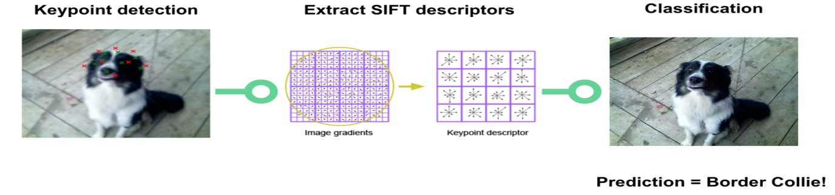

Dataset includes 8,350 images of 133 different dog breeds. We used Pythons cv2 library from OpenCV to calculate these SIFT descriptors.

**Identifying dog breed using CNN Architecture, by Kanika Bhavya**

This is a multiclass classification problem with 120 classes representing different breeds of dogs. Input is given as an image and the goal is to classify it to its appropriate class. The problem is tackled as an Image Classification problem using Deep Convolutional Neural Network. Further on, trans-fer learning technique is used to improve the accuracy. The set of data utilized in this study which is Stanford Dogs set of data, which contains 120 unique dog breeds and 10222 and 10357 images for training and testing respectively.

Transfer learning is an approach in DL where pre-trained models are used for building the model.

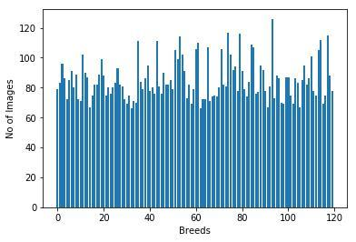

The images are augmented by flipping, zooming, shifting and rescaling by 255.

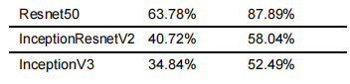

As an improvement and future work, data masking can be done on the train set. Noise from background of the images can be canceled by masking images.

**Dog breed Identification using DenseNet, by WentingShi and MuyunLiu**

This project is based on PR which is to identify the dog’s breed. Dataset contains 10,000+ images of 120 breeds of dogs, we use 4 methods to do the identification. Each method has a different training model. The four models are ResNet18, VGG16, DenseNet161, and AlexNet.Based on our models, we also make some improvements on the optimization methods to increase our identification accuracy.This paper proposes DensNet model is best with accuracy of 85.14%.

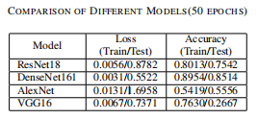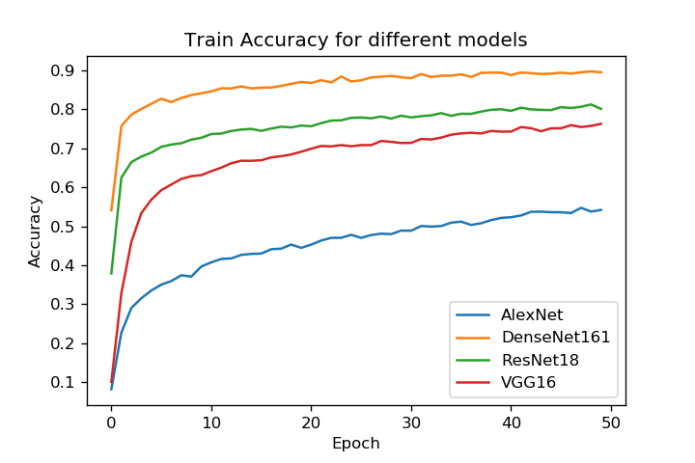

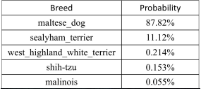

**Dog Breed Identification using CNN and WebScraping, by Praveen**

The current paper presents the methodology of fine-tuning CNN which is implemented in Stanford dog breed dataset. There are several fine-tuned transfer learning which are widely used. In this application, Inception-ResNet-V2 [3]are implemented over the dataset. Web Scraping or Web Data Extraction is a technique employed to extract large amount of data from websites. It automates the process, so that instead of manually copying the data from websites, the web scraping will perform the same task within a fraction of the time.The Stanford dog breed dataset contains images of 120 breeds and there are 20,580 images in the dataset.

In this present paper, Inception-ResNet-v2 has been utilized in order to fetch the better performance. This network is 164 layers deep and classify images into 1000 objects. The data model has to be saved for the further usage. In this current paper, the flow of the application has split majorly into 2 segments. Firstly, image processing using neural network. Secondly, data rendering using web scraping.

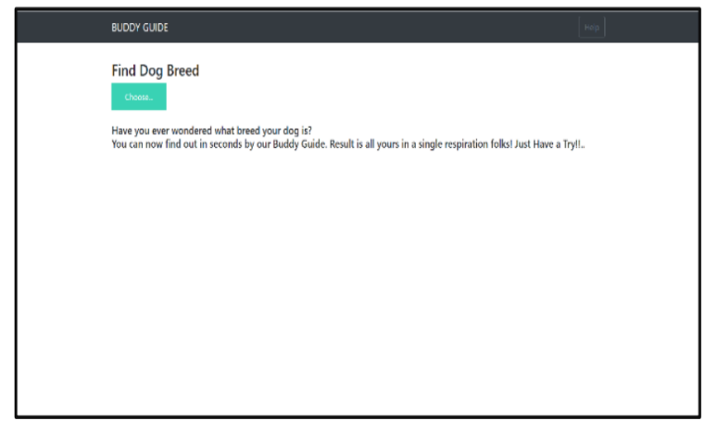

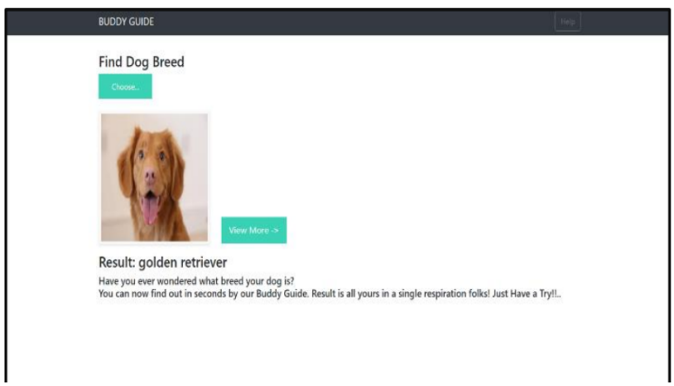

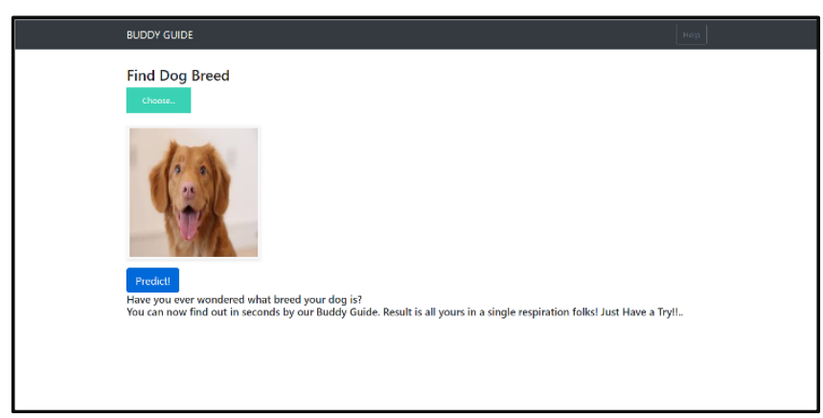

**Convolutional Neural Network with Bi-directional Long Short-Term Memory Approach for Image Captioning, by Suramya Patel**

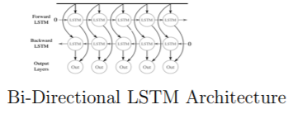This paper introduces a novel neural systems design that Convert Image into Sentences utilizing a half and half bidirectional LSTM with CNN Approach. Convolutional neural networks (CNN) have turned out to be mainstream in picture handling for include extraction. They Prove bi-directional LSTM Perform better than another neural network. Bi-directional demonstrate by nourishing sentence to LSTM from forward and in reverse arrange so utilize of both the past and future setting data of a sentence in foreseeing word. To beginwith its Taking Input from CNN Extricated Features.

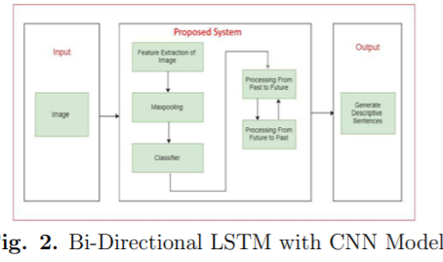

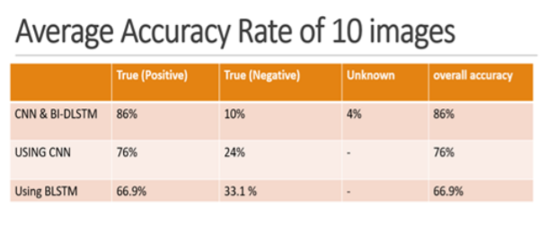

By going through the above research papers,we conclude that CNN is best for image classification related tasks due to its excessive accuracy. We define a CNN based approach for spotting dogs in perchance complex images and due to this fact reflect inconsideration on the identification of the one of kinds of dog breed.

Bidirectional long-short term memory(bi-lstm) is the process of making any neural network o have the sequence information in both directions backwards (future to past) or forward(past to future).

**CHAPTER 3- PROBLEM DEFINITION**

* We are provided with a training set and a test set of images of dogs.
* Each image has a filename that is its unique id.
* The data set comprises 120 breeds of dogs.
* The goal is to create a classifier capable of determining a dog's breed from a photo.
* In this Task, we were provided a strictly canine subset of Image-Net in order to practice fine-grained image categorization.
* How well can we tell our Norfolk terriers from our Norwich terriers.
* With 120 breeds of dogs and a limited number training images per class, we might find the problem more challenging than we anticipated.

**CHAPTER 4- SYSTEM REQUIREMENTS SPECIFICATION**

* The main purpose of this project is to distinguish between different breed of dogs and to know about the same.
* The minimum **hardware requirements** for faster processing is as follows:
* Deep learning is a very CPU intensive program-esque thing to be running, so be prepared to shell out a lot of money for a good enough system. Here are some system requirements to adhere to (parenthesis are what you can maybe get away with)
* Quad core Intel Core i7 Skylake or higher (Dual core is not the best for this kind of work, but manageable)
* 16GB of RAM (8GB is okay but not for the performance you may want and or expect)
* M.2 PCIe or regular PCIe SSD with at least 256GB of storage, though 512GB is best for performance. The faster you can load and save your applications, the better the system will perform. (SATA III will get in the way of the system’s performace)
* Premium graphics cards, so things with GTX 980 or 980Ms would be the best for a laptop, and 1080s or 1070s would be the best for the desktop setup. (try not to sacrifice too much here. While a 980TI or a 970m may be cheaper, this is also a critical part of the system, and you’ll see a performance drop otherwise.)
* The minimum **software requirement**s are:
* A Python editor or IDE such as VScode,Pycharm,Spyder etc..
* You should have installed some of the Modules/Packages like Keras,TensorFlow
* These functions are particularly required in Image Classification:-

from keras.models import Sequential

from keras.layers import Convolution2D,MaxPool2D,Flatten,Dense

from keras.preprocessing.image import ImageDataGenerator

* ****Operating System**** — Microsoft Windows 10 (64-bit recommended) Pro or Home. It is recommend updating Windows 10 to the latest version before proceeding forward.

**CHAPTER 5- SYSTEM DESIGN**

**System Architecture:** The android application has four major activities.

Top 3 predictions

Gets a picture

Instructions of the app

Description of all 120 Breeds

View

Take photo

Upload

Application

Instruction

**Dataset used:** To train the model, we have used Kaggle dog’s dataset.This dataset has 120 different dog breed images.Whole dataset is divided into:

* Train data
* Validation data
* Test data

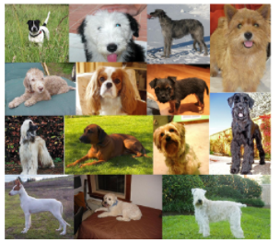

**Feature Extraction From Images:** This is done using a pre-trained model.

* RGB image of dog:

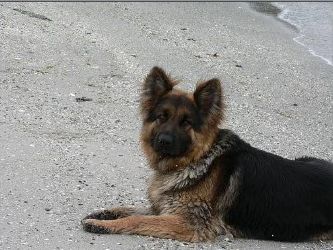

* Grey scale of the image:

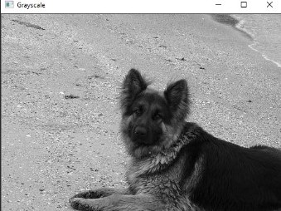

**Dog Breed Identification On Android:**

Keras model is converted to tensorflow protobuff file.

Steps are:

* Run Keras model on the server.
* Convert the model to a tensor protobuff file.
* Save the latest checkpoint.
* Freeze the graph.
* Finally optimize the saved model.

**CHAPTER 6- CONCLUSIONS**

* Convolutional neural network is a learning method for data analysis and predictions, now days it also become very popular for image classification problems. Dog breed prediction of deep learning developed using convolutional neural network is to predict the breed of hundred images in taking their images as input.
* Based on the literature review of five research papers we have proposed to use CNN method for our project by using bi-directional LSTM model.
* Data set for the implementation of this project has been collected that includes 120 breeds of dogs where each image having a unique id to distinguish them.
* The system architecture for building the android application has also been drafted that includes what feartured to be added like taking picture of dog,uploading picture etc.
* The future work includes the processing of dog images present in dataset for training the model and getting the appropriate accuracy.
* The android application here acts as UI element for interaction between dog images and model.
* Future work should further explore the potential ofconvolutional neural networks in dog breed prediction.
* Neural networks take an enormous time to train, so its recommended urther exploration into neural networks for keypoint detection, specifically by training networks with a different architecture and batch iterator to see what approaches might have greater success.
* 9. Ultimately, neural networks are time consuming to train and iterate upon, which should be kept in consideration for future efforts; still, neural networks are formidable classifiers that will increase prediction accuracy over more traditional techniques.

**REFERENCES**